Claude Certification — Building with the Claude API
Section 4 — Prompt Engineering Techniques
Contents
- Lesson 1 — Prompt Engineering
- Lesson 2 — Being Clear and Direct
- Lesson 3 — Being Specific
- Lesson 4 — Structure with XML Tags
- Lesson 5 — Providing Examples

Lesson 1 — Prompt Engineering

Core idea
Prompt engineering means taking a prompt you've already written and improving it through a repeatable cycle: write it, evaluate it, apply a technique, and re-evaluate to confirm the change actually helped.

Key points
- Cycle: set a goal → write an initial prompt → evaluate → apply a technique → re-evaluate — the last two repeat until performance is acceptable.
- PromptEvaluator handles dataset generation and grading; max_concurrent_tasks caps parallel test cases — start at 3 to avoid rate limits.
- generate_dataset() builds test cases from task_description + prompt_inputs_spec; keep num_cases low (2–3) while iterating.
- The first prompt is deliberately naive — it only exists to set a baseline score to beat.
- extra_criteria tells the grader what a good answer must specifically include.
- A low first score (e.g. 2.3/10) is normal — the goal is measurable improvement across iterations, not a perfect first try.
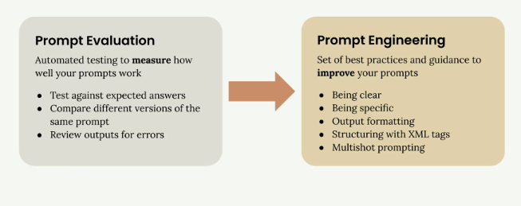
Evaluation measures how well a prompt works; engineering is the toolkit used to improve it.

The Iterative Improvement Process
The cycle has five steps: set a goal, write an initial prompt, evaluate it, apply an engineering technique, then re-evaluate to confirm the change helped. Only the last two steps repeat, looping until the score is good enough.
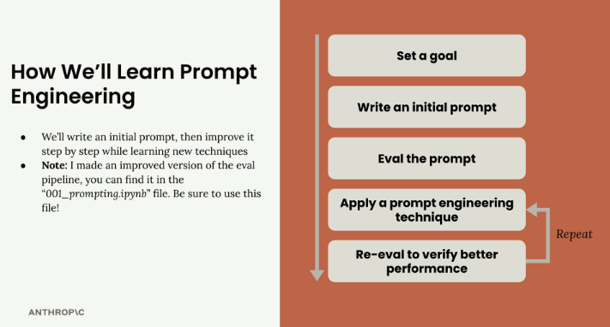
The five-step loop this section follows, repeating "apply a technique" and "re-evaluate."

Setting Up Your Evaluation Pipeline
The PromptEvaluator class wraps dataset generation and grading behind one object. Its max_concurrent_tasks parameter controls how many test cases run in parallel — start low, like 3, to avoid rate-limit errors, and raise it later if your quota allows.

Generating Test Data
generate_dataset() builds test cases automatically from a task_description and a prompt_inputs_spec dictionary naming each input the prompt needs. Keep num_cases low (2–3) during development so each iteration stays fast; raise it only for a final validation pass.

Writing Your Initial Prompt
The first prompt is deliberately weak — for the meal-plan example, little more than "What should this person eat?" wrapped in a run_prompt() function. It exists only to give you a baseline score to improve on.
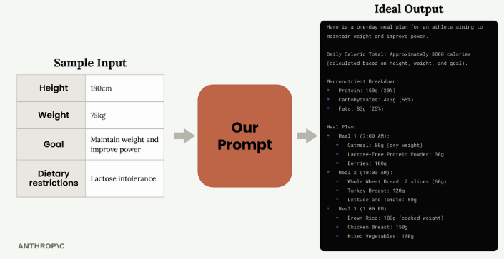
The meal-plan example: athlete attributes in, a well-formed one-day meal plan out.
def run_prompt(prompt_inputs):
prompt = f"""
What should this person eat?

- Height: {prompt_inputs["height"]}
- Weight: {prompt_inputs["weight"]}
- Goal: {prompt_inputs["goal"]}
- Dietary restrictions: {prompt_inputs["restrictions"]}
"""
messages = []
add_user_message(messages, prompt)
return chat(messages)

Adding Evaluation Criteria
run_evaluation() accepts an extra_criteria string so the grader checks requirements specific to the task — for the meal plan, that means caloric total, macronutrient breakdown, and exact meals with portions and timing.

Analyzing Results
Each run produces an average score plus a detailed HTML report with per-test-case inputs, output, score, and reasoning. A first score as low as 2.3/10 is typical — the report's reasoning shows exactly what to fix next.
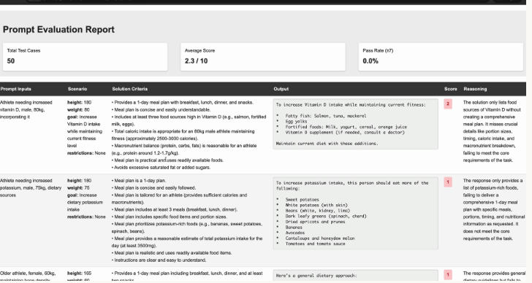
The HTML report: inputs, criteria, output, score and reasoning per test case — this baseline averaged 2.3/10.

Table
Parameter | Belongs to | Purpose
max_concurrent_tasks | PromptEvaluator(...) | Caps parallel test cases; start low to avoid rate limits
task_description | generate_dataset(...) | What the prompt should accomplish
prompt_inputs_spec | generate_dataset(...) | Dict naming each input the prompt needs
num_cases | generate_dataset(...) | How many test cases; keep low during dev
extra_criteria | run_evaluation(...) | Use-case-specific grading requirements

Practice Questions — Lesson 1
Choose the single best answer for each question (A–E).
1. In the iterative improvement cycle, which two steps repeat until you're satisfied with performance?
A) Set a goal and write an initial prompt
B) Write an initial prompt and evaluate the prompt
C) Apply a prompt engineering technique and re-evaluate
D) Evaluate the prompt and set a goal
E) None — each step runs exactly once
2. What is the recommended starting value for max_concurrent_tasks?
A) 1
B) 3
C) 10
D) 50
E) There is no default guidance
3. Why should num_cases stay low (2–3) during development?
A) The API rejects larger datasets
B) It keeps the iteration cycle fast while you're still refining the prompt
C) Model graders can only grade 3 cases at a time
D) It reduces the max_tokens needed
E) It's required for the HTML report to render
4. What is the purpose of extra_criteria in run_evaluation()?
A) To set the grading temperature
B) To limit tokens the model can generate
C) To tell the grading model about requirements specific to your use case
D) To choose which model grades the output
E) To select the stop sequence
5. Why is a first-attempt score like 2.3/10 considered normal?
A) The grading model is deliberately harsh on the first run
B) The baseline prompt is intentionally naive, so a low score just gives room to measure improvement
C) Scores under 5 aren't counted
D) It means the dataset was generated incorrectly
E) It indicates the API key lacks billing

Lesson 2 — Being Clear and Direct

Core idea
The first line of a prompt sets the stage for everything that follows. Being clear (simple, unambiguous language) and being direct (an instruction with an action verb) made the meal-plan baseline's score jump from 2.32 to 3.92.

Key points
- Clear = simple language, state exactly what you want, lead with the task.
- Direct = instructions, not questions; open with an action verb — "Write," "Create," "Generate."
- Baseline rewrite: "What should this person eat?" → "Generate a one-day meal plan for an athlete that meets their dietary restrictions."
- Result: score moved from 2.32 to 3.92 from restructuring only the opening line.
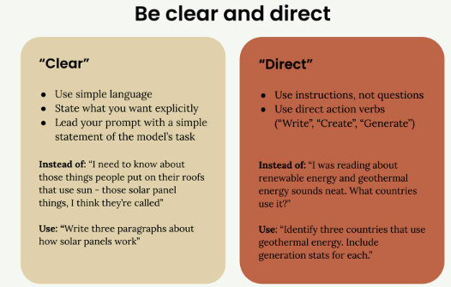
Clear = simple, unambiguous language. Direct = phrased as an instruction, opening with an action verb.

Clear Communication
Being clear means using language anyone could understand, stating exactly what you want, and leading with a straightforward statement of the task. "I need to know about those things people put on their roofs that use sun" becomes "Write three paragraphs about how solar panels work."

Direct Instructions
Being direct means phrasing the request as an instruction and opening with a concrete action verb. "I was reading about renewable energy and geothermal energy sounds neat. What countries use it?" becomes "Identify three countries that use geothermal energy. Include generation stats for each."

Putting It Into Practice
The meal-plan baseline, "What should this person eat?", is rewritten as "Generate a one-day meal plan for an athlete that meets their dietary restrictions." That single line now tells Claude the action to take, what to create, and the key constraints.

Results Matter
This one change moved the evaluation score from 2.32 to 3.92 — nothing else about the prompt changed. Treat Claude like a capable assistant that needs clear direction, not someone who has to guess.

Table
Context | Vague / question | Clear and direct
Solar panels | “Those things people put on their roofs that use sun…” | “Write three paragraphs about how solar panels work.”
Geothermal energy | “Geothermal energy sounds neat. What countries use it?” | “Identify three countries that use geothermal energy. Include generation stats for each.”
Meal plan (baseline) | “What should this person eat?” | “Generate a one-day meal plan for an athlete that meets their dietary restrictions.”

Practice Questions — Lesson 2
Choose the single best answer for each question (A–E).
1. Which part of a prompt is described as the most important part of the entire request?
A) The system prompt
B) The last sentence
C) The first line
D) The list of constraints
E) The examples section
2. Which pair correctly matches “clear” and “direct” to what each governs?
A) Clear = structure; Direct = vocabulary
B) Clear = simple, unambiguous language; Direct = phrasing as an instruction with an action verb
C) Clear = length; Direct = temperature
D) Clear = XML tags; Direct = examples
E) They mean the same thing
3. Which of these is an example of being “direct” rather than just “clear”?
A) Using simple vocabulary
B) Avoiding jargon
C) Starting with an action verb like “Generate” instead of asking a question
D) Keeping the prompt short
E) Writing in complete sentences
4. What three things does “Generate a one-day meal plan for an athlete that meets their dietary restrictions” communicate in one line?
A) Temperature, model, and max_tokens
B) Grader, dataset, and score
C) The action to take, what to create, and the key constraints
D) System prompt, user message, and pre-fill
E) Goal, dataset, and extra_criteria
5. Applying only the clear-and-direct rewrite moved the evaluation score from:
A) 2.32 to 3.92
B) 0 to 10
C) 3.92 to 7.86
D) 1 to 2.32
E) 5 to 8

Lesson 3 — Being Specific

Core idea
Being specific means listing the qualities the output should have, providing the steps Claude should follow, or both — adding guidelines alone raised the meal-plan score from 3.92 to 7.86.

Key points
- Output Quality Guidelines control length, structure/format, specific elements, and tone.
- Process Steps give Claude a sequence to follow — useful for systematic thinking or multiple perspectives.
- Rule of thumb: always use guidelines; use steps for complex problems (troubleshooting, decisions, critical thinking, wider view).
- Impact: adding guidelines moved the score from 3.92 to 7.86.
- Professional prompts often combine both: guidelines for consistency, steps for thorough reasoning.
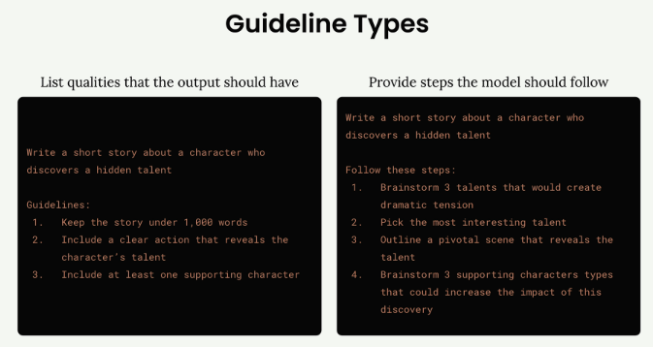
The two guideline types: listing output qualities (left) versus providing steps to follow (right).

Output Quality Guidelines
Guidelines list the qualities the finished output must have — for a short story, keeping it under 1,000 words, including a clear action revealing the character's talent, and adding a supporting character. They control length, structure, elements, and tone rather than the reasoning process.

Process Steps
Steps give Claude a sequence to work through before answering — for the same story: brainstorm three talents, pick the most interesting, outline the pivotal scene, then brainstorm supporting characters. This is useful when you want systematic thinking rather than a first-idea answer.

When to Use Each Approach
Use output guidelines in almost every prompt — they're the low-cost safety net for consistency. Reserve process steps for troubleshooting, decision-making, critical thinking, or anytime you want Claude to consider a wider view instead of fixating on one angle.
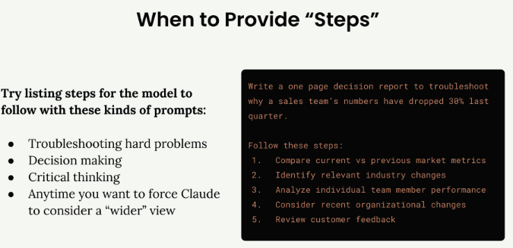
Reach for steps when troubleshooting, deciding, thinking critically, or forcing a wider view — shown with a sales-drop decision report.

Real-World Impact
Adding a guidelines block to the meal-plan prompt raised its score from 3.92 to 7.86 — more than double, from specificity alone:
Guidelines:
1. Include accurate daily calorie amount
2. Show protein, fat, and carb amounts
3. Specify when to eat each meal
4. Use only foods that fit restrictions
5. List all portion sizes in grams
6. Keep budget-friendly if mentioned

Combining Both Approaches
Professional prompts often layer guidelines and steps together: guidelines fix the shape of the output, steps ensure Claude actually considered the important angles. Together they deliver consistency and confidence in the reasoning behind the result.

Table
 | Output guidelines | Process steps
Controls | What the output looks like | How Claude reasons to the output
When to use | Almost always | Complex problems, wider-view tasks
Meal-plan effect | Score: 3.92 → 7.86 | Not isolated in this lesson

Practice Questions — Lesson 3
Choose the single best answer for each question (A–E).
1. Which type of guideline controls the length, structure, and tone of Claude's output?
A) Process steps
B) Output quality guidelines
C) System prompts
D) Stop sequences
E) Assistant pre-fill
2. Which type of guideline should be included in almost every prompt you write?
A) Process steps
B) Output quality guidelines
C) Neither is needed
D) Only steps, never guidelines
E) Only for creative writing
3. Process steps are most useful for which of the following?
A) Simple factual lookups
B) Formatting a response as JSON
C) Troubleshooting, decision-making, and critical-thinking tasks
D) Setting the temperature parameter
E) Reducing token usage
4. Adding a guidelines block to the meal-plan prompt moved the score from:
A) 0 to 2.32
B) 2.32 to 3.92
C) 3.92 to 7.86
D) 7.86 to 10
E) 1 to 5
5. Why do professional prompts often combine guidelines with process steps?
A) The API requires both parameters
B) Guidelines give consistent format while steps ensure thorough reasoning
C) Steps alone always outperform guidelines
D) To reduce tokens used
E) They're the same technique with different names

Lesson 4 — Structure with XML Tags

Core idea
When a prompt has a lot of content, Claude can struggle to tell which pieces belong together. Wrapping distinct parts — data, code, docs — in descriptive XML tags creates clear delimiters.

Key points
- Use tags to separate distinct portions of a prompt and serve as delimiters for Claude.
- Tag names are descriptive, not fixed: <sales_records> beats <data>.
- Most useful with: large context, mixed content types, or multiple interpolated variables.
- Value scales with complexity — bigger, more varied prompts benefit most.

Why Structure Matters
Without clear boundaries, Claude can struggle to tell your instructions apart from the data you want analyzed. Wrapping interpolated sales records as <sales_records>{sales_records}</sales_records> gives that block an explicit start and end.
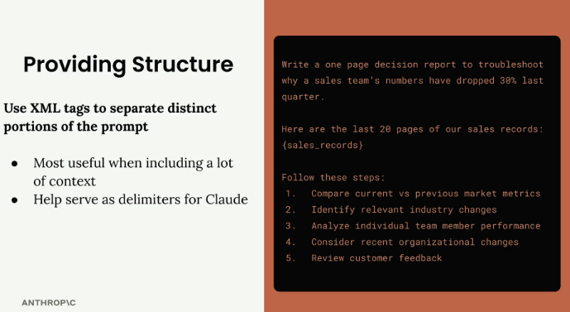
Without a delimiter, the interpolated data has no visible boundary against the surrounding instructions.
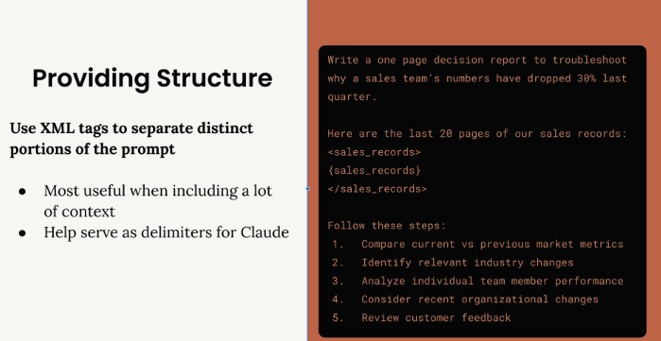
Wrapped in <sales_records> tags, the same data has an explicit start and end point.

Practical Example: Code and Documentation
Mixing raw code and documentation with no separation makes it hard to tell which is which — the “Not Great” version. Wrapping them as <my_code> and <docs> resolves the ambiguity immediately — the “Better!” version.
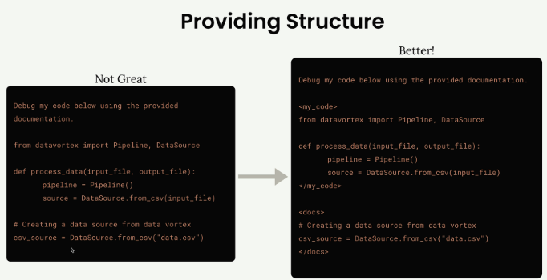
“Not Great”: code and docs mixed together. “Better!”: <my_code> and <docs> tags make each unmistakable.

Custom Tag Names
Tags aren't fixed vocabulary — pick descriptive names. <sales_records> beats <data>; <athlete_information> is clearer than an unlabeled block of stats. The more specific the name, the less guessing Claude has to do.

When to Use XML Tags
Reach for tags when including large amounts of context, mixing content types, wanting extra clarity on boundaries, or interpolating multiple variables. Even short content benefits, since tags still make structure obvious.

Real-World Application
Wrapping the athlete's attributes makes clear they're one related unit feeding the instruction that follows:
<athlete_information>
- Height: 6'2"
- Weight: 180 lbs
- Goal: Build muscle
- Dietary restrictions: Vegetarian
</athlete_information>

Generate a meal plan based on the athlete information above.

Table
Content | Generic (avoid) | Descriptive (prefer)
Sales data | <data> | <sales_records>
User attributes | <info> | <athlete_information>
Source code / docs | <content1> / <content2> | <my_code> / <docs>

Practice Questions — Lesson 4
Choose the single best answer for each question (A–E).
1. What core problem do XML tags solve when a prompt interpolates a lot of content?
A) They reduce token usage
B) They give Claude clear delimiters for what belongs together and what each section represents
C) They lower the temperature automatically
D) They replace the system prompt
E) They validate JSON syntax
2. In the code-and-documentation example, what made the "Not Great" version hard to parse?
A) A syntax error in the code
B) The documentation was in a different language
C) Code and documentation were mixed with no separation
D) It exceeded max_tokens
E) It used the wrong model
3. Which tag name is preferable for a block of sales data?
A) <data>
B) <content>
C) <info>
D) <sales_records>
E) <block1>
4. Which of these is NOT listed as a situation where XML tags are most useful?
A) Large amounts of context or data
B) Mixing content types like code and documentation
C) Wanting extra clarity on boundaries
D) Prompts interpolating multiple variables
E) Lowering the max_tokens parameter
5. What does wrapping height, weight, goal, and restrictions in <athlete_information> communicate to Claude?
A) They must be validated as JSON first
B) They're one related unit to consider together for the meal plan
C) They should be excluded from the response
D) A different model should process this section
E) The values are optional

Lesson 5 — Providing Examples

Core idea
Giving Claude sample input/output pairs — one-shot or multi-shot prompting — shows what a good response looks like instead of only describing it, which is especially valuable for corner cases like sarcasm.

Key points
- One-Shot = a single example; Multi-Shot = multiple examples covering different scenarios.
- Useful for: corner cases, complex formats, exact tone, ambiguous inputs.
- Combine with XML tags: <sample_input> / <ideal_output>.
- Source examples from your highest-scoring eval outputs rather than inventing them.
- Explain why an output is ideal, not just show it.
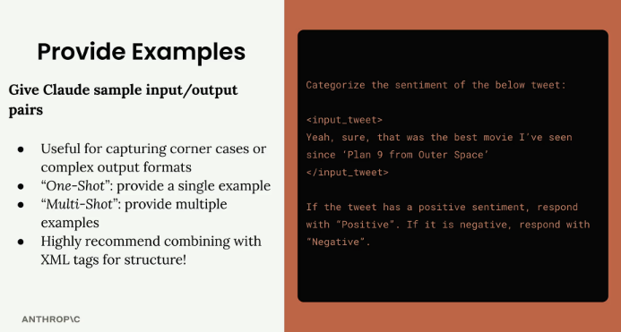
Give Claude sample input/output pairs, ideally wrapped in XML tags.

How Examples Work
A tweet like “Yeah, sure, that was the best movie I've seen since 'Plan 9 from Outer Space'” reads as positive by its words, but it's sarcastic and actually negative — the kind of corner case an instruction alone struggles to convey.

Adding Examples to Handle Corner Cases
Wrapping demonstration pairs in <sample_input> / <ideal_output> tags fixes this: a plain positive example (“Great game tonight!” → Positive) plus a sarcastic one (“Oh yeah, I really needed a flight delay tonight! Excellent!” → Negative), with a note to be careful with sarcasm.
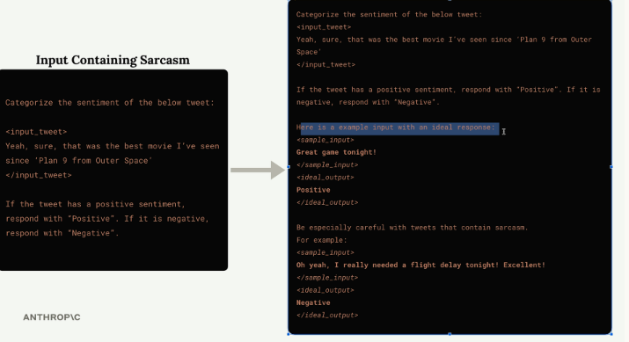
The sentiment prompt improved with a labeled example pair and a warning to handle sarcastic tweets carefully.

One-Shot vs Multi-Shot
One example is enough to establish a single dominant pattern. Multiple examples are needed to cover distinct edge cases — the sentiment prompt needs both a plain example and a sarcastic one, since one alone wouldn't teach the other failure mode.

Finding Good Examples from Evaluations
Rather than inventing examples, mine your own eval pipeline: find the test cases that scored highest (e.g. 10/10) and reuse those input/output pairs directly as the examples baked into the prompt.

Adding Context to Examples
A bare ideal_output shows the correct shape but not why it's correct. Appending a short explanation afterward teaches Claude the reasoning behind a good response, not just its format:
<ideal_output>
[Your example output here]
</ideal_output>

This example is well-structured, provides detailed information
on food choices and quantities, and aligns with the athlete's
goals and restrictions.

Best Practices
Always use XML tags; be explicit that you're showing an example (“Here is an example input with an ideal response”); prioritize examples covering your most common failure cases; explain why each output is ideal; keep examples relevant to the task.

Table
 | One-shot | Multi-shot
Examples | A single example | Multiple examples
Purpose | Establish the basic pattern | Cover different scenarios/edge cases
Sentiment example | Only the positive case | Positive + sarcastic (negative) case

Practice Questions — Lesson 5
Choose the single best answer for each question (A–E).
1. What is the term for giving Claude a single sample input/output pair to establish a pattern?
A) Multi-shot prompting
B) One-shot prompting
C) Zero-shot prompting
D) Chain-of-thought prompting
E) Structured output prompting
2. Why does the sarcastic tweet about “Plan 9 from Outer Space” require a special example rather than just a clearer instruction?
A) It contains a spelling error
B) It's sarcastic, so it reads as positive on the surface but is actually negative
C) It exceeds max_tokens
D) It contains a movie title that must be censored
E) It's written in a different language
3. Where should you look to find good candidate examples for a prompt?
A) Randomly generated test cases
B) The lowest-scoring outputs, to show what to avoid
C) The highest-scoring outputs from your evaluation
D) An unrelated prompt
E) The system prompt documentation
4. What should accompany an <ideal_output> example, per best practices?
A) A stop sequence
B) A temperature value
C) A short explanation of why that output is ideal
D) The model's confidence score
E) A second, contradictory example
5. Which combination does the lesson highly recommend for structuring examples?
A) Examples with a lower temperature
B) Examples with XML tags
C) Examples with a longer system prompt
D) Examples with extended thinking
E) Examples with stop sequences only

